VCS Task

Task Description:

Establish a new directory, populate it with script files, initiate an empty repository on GitHub, convert the local directory into a Git repository, and link it to GitHub for pushing the code into the repository.Perform merge, rebase, stash commands in following github repo.

Techstacks needs to be used :

- Shell (AWS, WSL, Vbox)
- Git (Gitbash)

OUTPUT:-

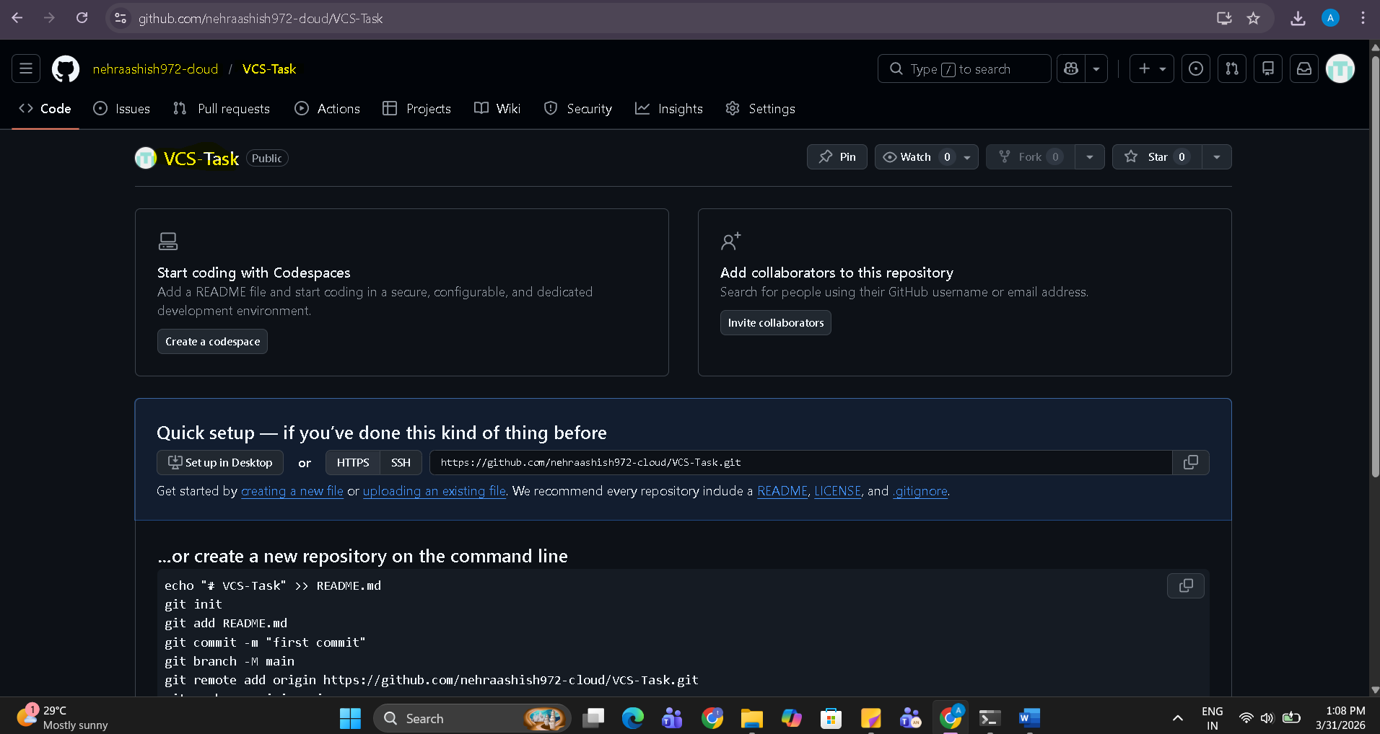
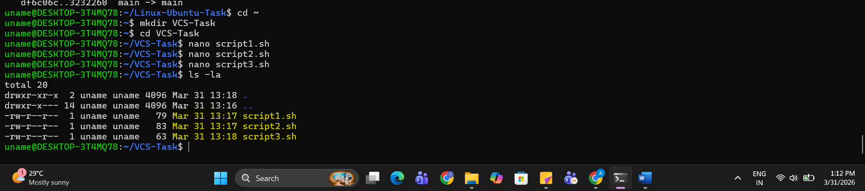

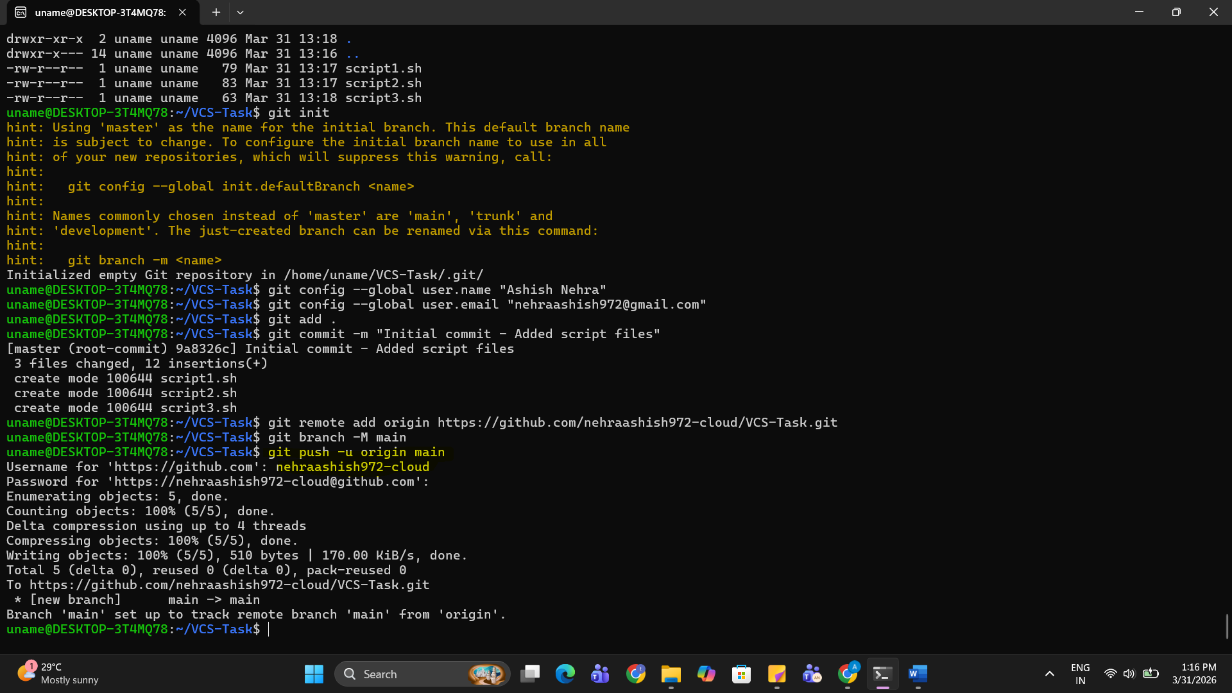

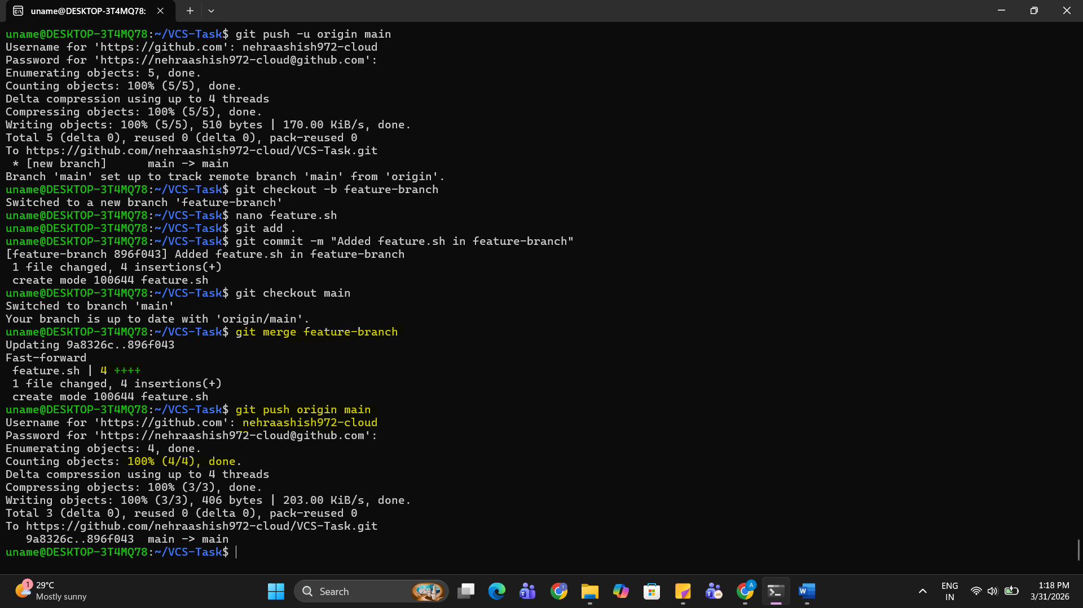

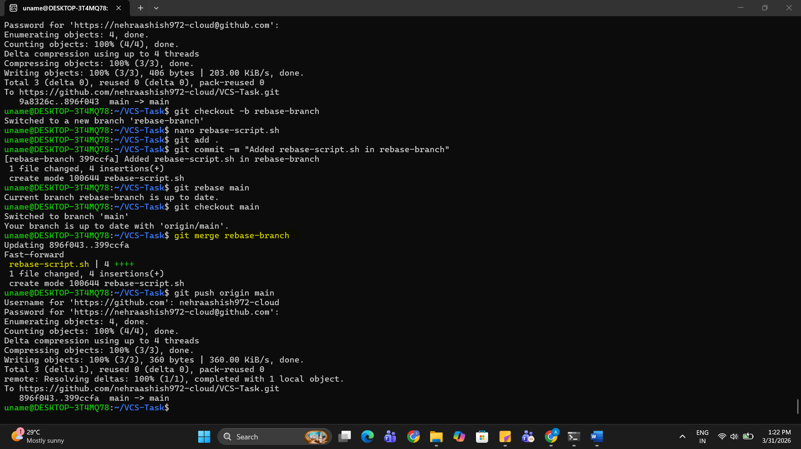

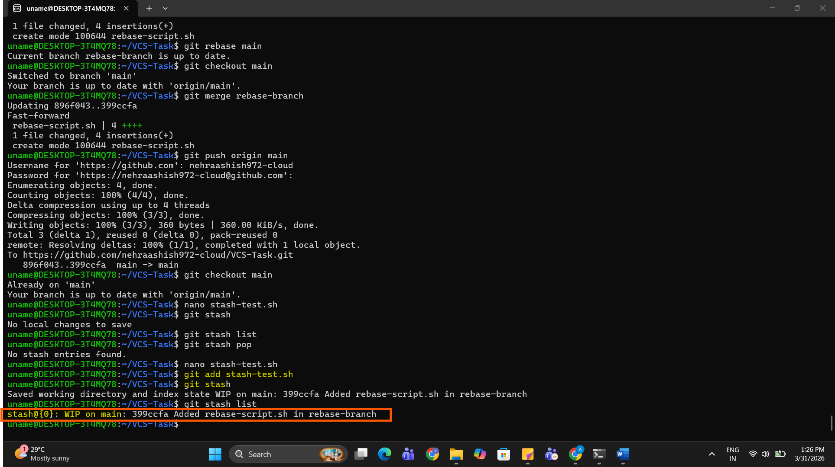

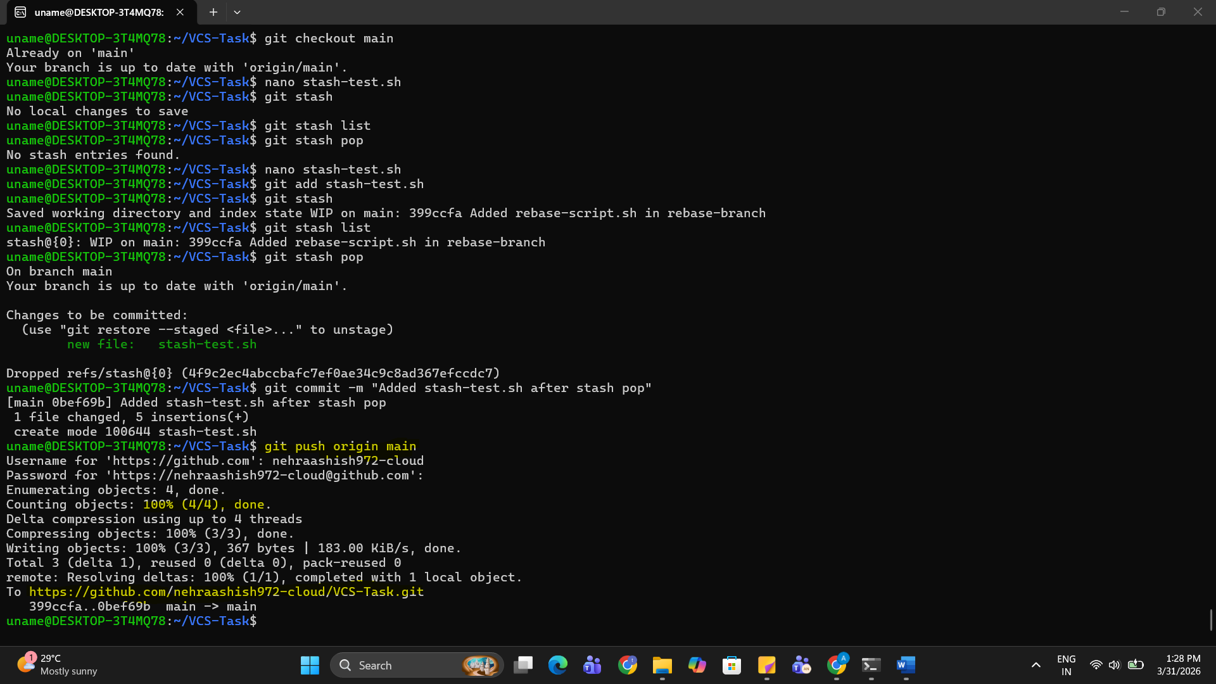

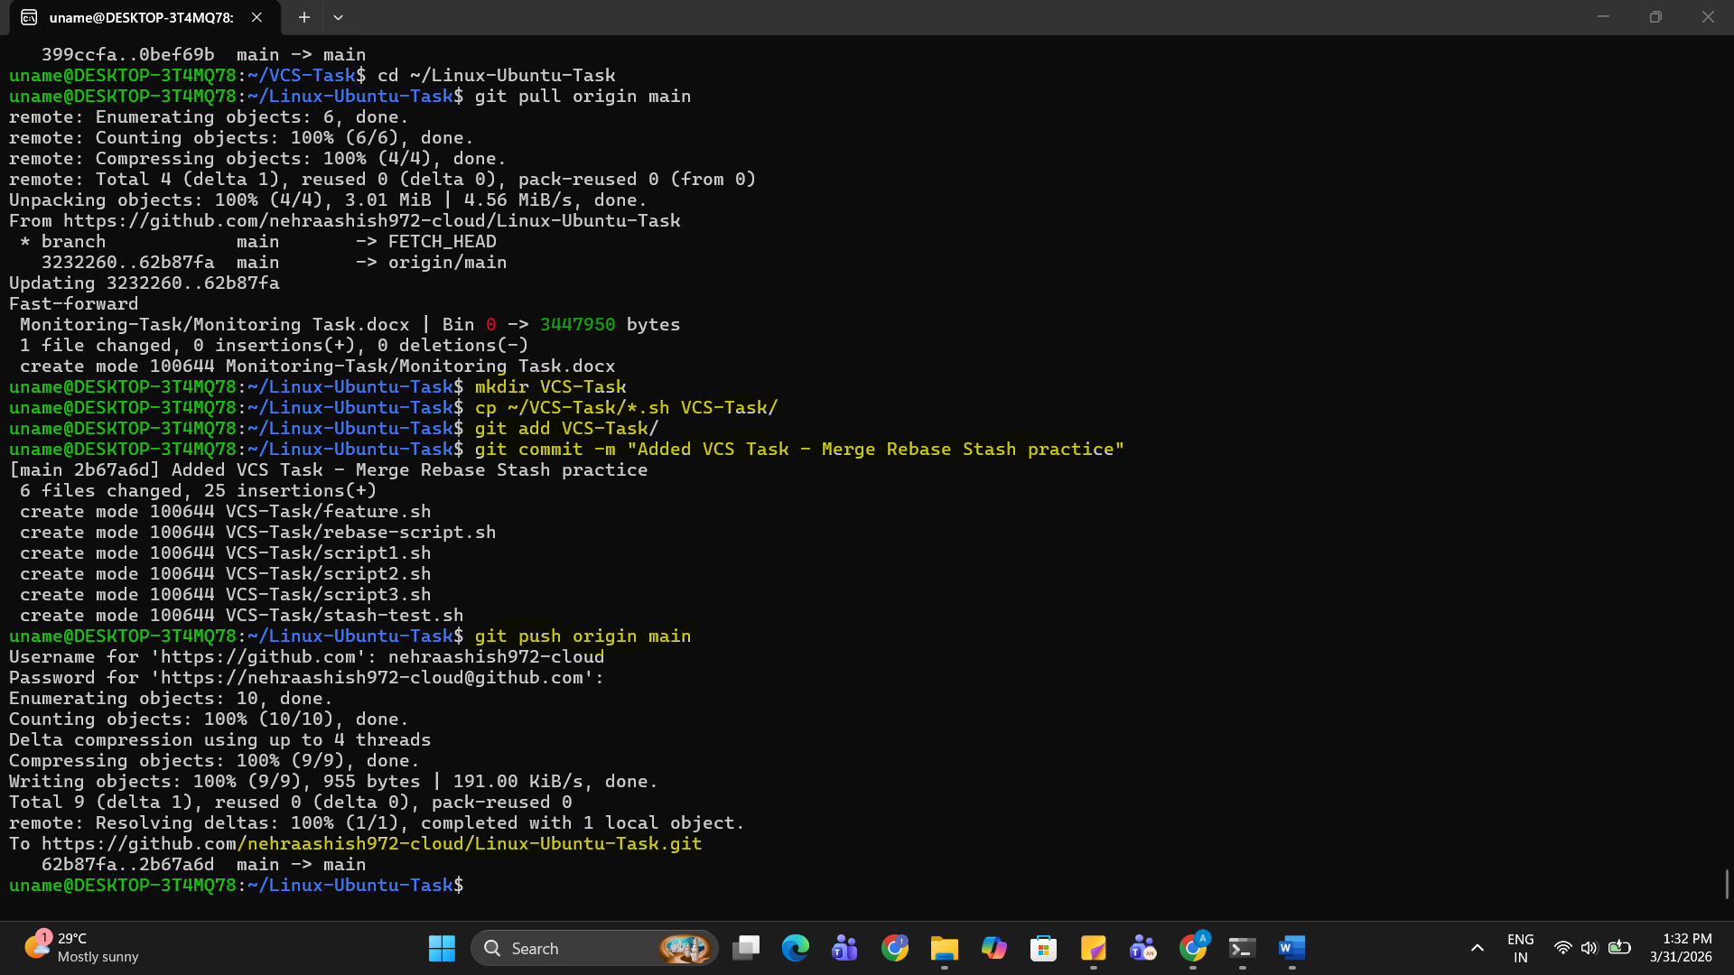

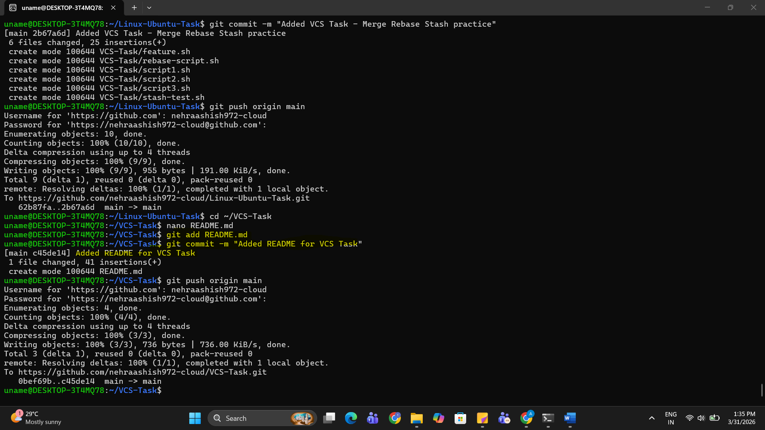

1. Linux-Ubuntu-Task repo URL:
https://github.com/nehraashish972-cloud/Linux-Ubuntu-Task
2. VCS-Task repo URL:
https://github.com/nehraashish972-cloud/VCS-Task

